
Starship SHOOTER


Christopher sinclair
Praxis Programing

Table of Contents
A Brief Description of the Game 2
How it works 2
Main Game Loop 3
GamePlay and Paused screen 3
End Screen 4

A Brief Description of the Game
The game I made is a game loosely based on Space Invaders and Galaga. When you run the game, a screen will appear showing some text which says, “Christopher Sinclair Game Project Praxis Programming”. This screen will show for 2 seconds then switch to the title screen which shows the name of the game and prompts you to press enter. Once enter has been pressed the game will start, the players is drawn same with the score (start on 0) and number of life’s the player has which is 5 the controls are as follows – to move press WASD, W = up, A = left, S = down, D = down, to shoot the asteroids press SPACE and to pause the game press ENTER. If you are hit by the asteroids the lives value will go down once the lives value reaches 0 that’s game over and you will be prompted to press enter to play again. When you shoot an asteroid the score value will increase by 10 and when you die your final score will be displayed.

How it works
This is a Flowchart of the main game loop it starts out initializing and opening the main game window then the FPS is set using the variable that is defined at the top of the code called FPS which is set to 60. Then the local variables are initialized using the structures defined at the top of the code which are Player, Shot, Asteroid, Ship Texture, GameScreen and a Boolean called gamePaused. These variables will then get their values assigned to them using the function InitGame which take in parameters of Player, Asteroid, Shot and Ship texture, this function sets the Ship texture, Game Background texture, Player position, speed, HP and score, Asteroid active state, radius and speed, Shot active state and Shot radius. The game loop then checks if the window is open, if it is then it will check what value the GameScreen variable has and does the appropriate action depending on what the value is. The GameScreen is set to LOGO at first which shows my name and name of the course this shows for 2 seconds then switches to the TITLE which shows the name of the game which is STARSHIP SHOOTER. The game will check is the enter key is being pressed and if it is then the GameScreen will change to GAMEPLAY.
This is where everything happens, the UpdateGame function is called, this function uses the address of the Player, Asteroid, Shot, Screen and GamePaused variables. The function first checks if the GameScreen variable is equal to GAMEPLAY and that GamePaused is equal to false if these two conditions are met the Player movement starts. If any one of the keys WASD are pressed the Players position will be updated using the current Player position and the Players speed value. If the player is moving up the speed be taken away from the position and if the player is moving down then vice versa, if the player is moving left the speed is taken away from the position and if the player is moving right vice versa. If the space bar is being pressed and the Shot active state is equal to false meaning there isn’t already a shot on the screen, a shot will be drawn at the players current position and moved upwards until it either hits an asteroid or hits the window border.
When the enter key is pressed while in the main game screen the pause screen will show telling the player how to resume the game (pressing enter again). When an asteroid hits the player the players HP value will decrease by 1, if the asteroid hits the window border or is hit by a shot it will delete the asteroid. When the player’s HP reaches 0 the game over screen will be drawn showing the final score and prompting the player to either play again or exit the game. If the player chooses to play again the title screen will be drawn again setting all the players values back to default and if the player chooses to exit the game the textures will be unloaded to avoid memory leaks and the window will close.

Main Game Loop
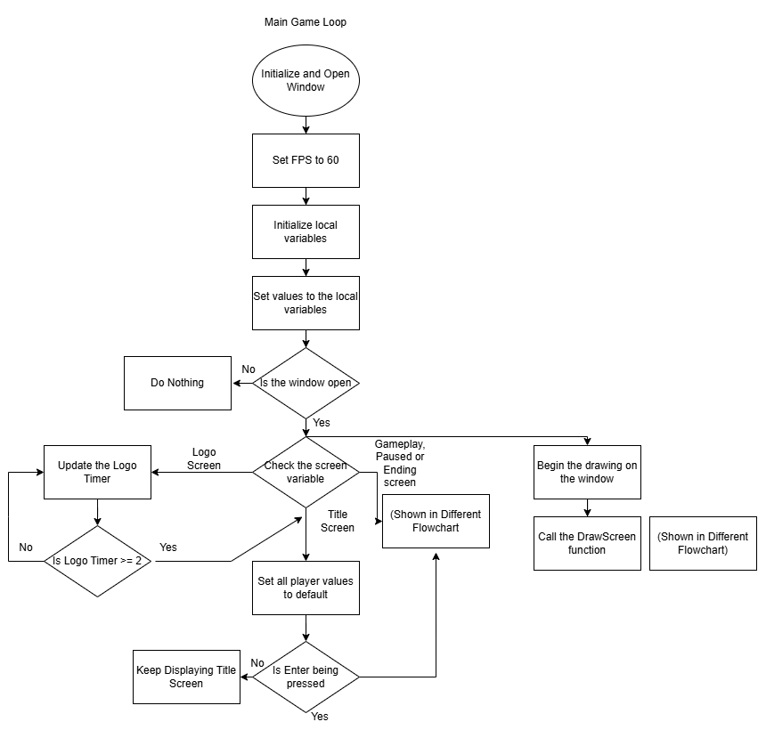

GamePlay and Paused screen

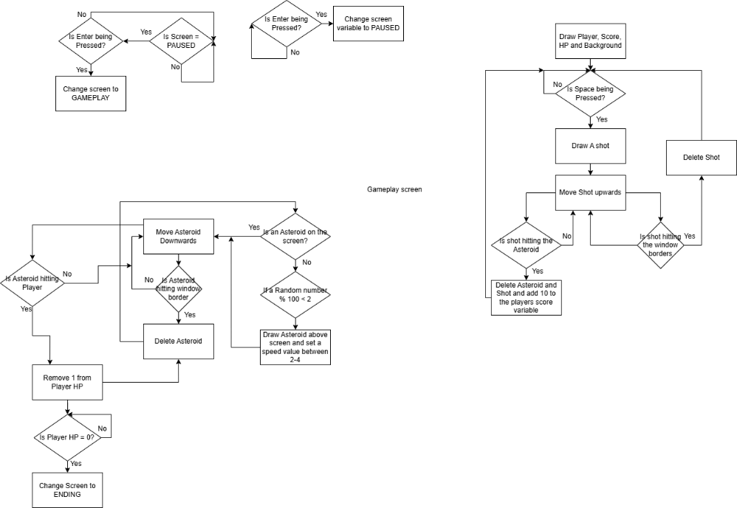

End Screen
